

**FAMILY FOUNDATION MANAGEMENT/COUNSEL**

Volume 1/Number 1 August 2014

©2014 FFM/C LLC. All rights reserved.



***FROM SHOEMAKER TO SHOEMAKER***

***IN THREE GENERATIONS!***

**It’s an old story winningly told** by **TOM ROGERSON** a senior director and wealth management advisor at **WILMINGTON TRUST COMPANY (trogerson@wilmingtontrust.com).** A 14th generation Mayflower descendant, still living on the family’s original land in Massachusetts, Tom is the scion of a wealthy Boston family that lost all its money – in three generations.

He weaves his personal story into solid wealth management advice for families. Speaking to a meeting of philanthropic advisors in Vancouver BC - members of the Giving Institute ([www.givinginstitute.org](http://www.givinginstitute.org)) - it is less a story about money itself but how family dysfunction and poor-to-non-existent communications among the family, from the paterfamilias downward, took away the wealth.

A recent study, Tom reported, showed that typically a family loses lost 80% of its wealth within 50 years of the founder’s death. **The takeaway for the emerging or recently established family foundation** – or for anyone thinking about starting one - is only partly about how the wealth will be managed, or by whom, but rather **the family dynamic. A dysfunctional family will end up with a dysfunctional foundation** – quarreling about the founders’ (usually parents) commitments versus the children’s interests – either philanthropic but commonly about money that they’d rather have themselves; about who’s in charge and how decisions are made. Tom’s presentation included this quote attributed to George Burns:

**“Happiness is having a large, loving, caring, close-knit family in another city.”**

 Tom Rogerson

***THE NEW POWER PARADIGM: HIGH ALERT FOR FAMILY FOUNDATIONS***

**GIVING TUESDAY**

Three years ago **HENRY TIMMS** executive director of the **92nd St Y** in New York convened a small group of us to talk about an idea for stimulating a big bump in charitable giving on the Tuesday following Thanksgiving Day, to somewhat counter the rampant commercialism of **Black Friday** and **Cyber Monday** the two biggest consumption-is-everything sales days of the year**.** **GIVING TUESDAY** ([www.givingtuesday.org](http://www.givingtuesday.org)) has since gone global as leaderless, peer-to-peer and web based in which *everyone* - any individual, corporation, charity, religious association, religious organization, club – anyone - can help stimulate charitable giving or give to whatever cause impels them. **GT** has stimulated a lot of new money, especially from people, often younger, who have not given to charity before. But more than it is building awareness. It has been embraced by business, nonprofits and millions of people.

The concept, Henry explains, rests on a new consideration of the dynamics of power and how power is distributed in a world of instant access to information – through computers, tablets, smart phones, etc. The internet is about a fundamental re-distribution of power, hopefully for the good. But alas, not always.

A

Most businesses, organizations and **family foundations** still run the old way: topdown and centralized. Older generations are accustomed to being in charge; younger people are much more interested in immediacy and peer-to-peer relationships – in everything from lending and lodging to taxis and restaurants. In just the last few year Uber and Airbnb have come along, both perfect examples of the way new power is disrupting the old order. Indeed “disruption” is the buzz word *de jour.* **GT** is another example: wide, free distribution; no centralized control.

Family Foundation Management/Counsel LLC helps individuals and families fully realize their philanthropic aspirations. We're not wealth managers or investment advisors. We are intensely and solely focused on a client's needs and philanthropic aspirations.

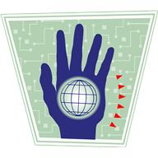

Old Power New Power

Currency Current

Held By Few Made By Many

Downloads Uploads

Commands Shares

Leader-Driven Peer-Driven

Closed Open

**HALF THE WORLD’S POPULATION IS UNDER THE AGE OF 30.**

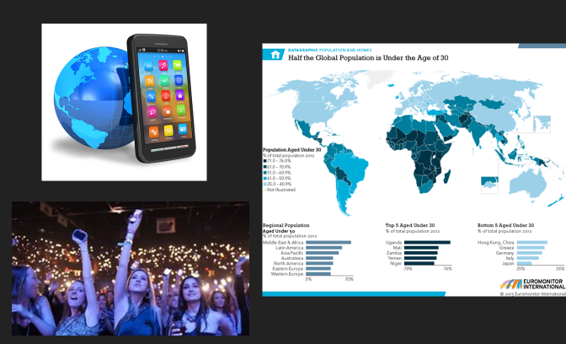

Both courtesy Henry Timms